Enhancing water quality – changing mindsets

Farmers leading implementation of sustainable water management solutions

“In the past 5 years, agricultural production in Ireland has been increasing significantly, so there is a growing need for sustainable farming practices to alleviate pressure on Ireland’s natural water bodies” – says Carol Quish, Project Manager of the Irish Mulkear Operational Group project that supports farmers to take the lead in mitigating agricultural impacts and enhancing water quality within the Mulkear catchment.

The Mulkear catchment in the Limerick and Tipperary counties of Ireland is considered ‘at risk’ because of a worrying decline in the water quality across the catchment. The Operational Group (OG) Mulkear-EIP has designed a programme to support farming activities, whilst bringing about catchment-scale improvements in water quality. “We wanted to implement a local, farmer-led collaborative partnership, to co-design an innovative suite of mitigation measures” Carol Quish explains.

The Mulkear-EIP OG launched an open call for farmers to join their programme. All of the farmers involved attend regular discussion group meetings. Together with the project team and other local stakeholders, they identify problems and co-create practical and sustainable water management solutions. All farming activities are represented, including dairy, suckler and beef cattle, to bring a balanced perspective to the discussion groups. “The discussion groups are about changing mindsets, raising awareness and capacity building, empowering farmers to address farming-related impacts on water quality, and it is also about co-design and co-development of applicable solutions” explains Carol.

The project team also works with each farmer to draw up an individual farm plan with specific measures to improve water quality. These include, for instance, nutrient management such as inclusion of clover and application of lime, grazing infrastructure like protecting water courses and farmland enhancement such as in-field mounds. One of the participant farmers explains: “One of the measures that we are applying is low emission slurry spreading, […] we have to be more conscious of the time of year and the weather when we spread. It gives a more efficient use of nitrogen while protecting the environment”. The farmers in the Mulkear catchment have traditionally spread manure in Autumn, even though at this time of year the ground is waterlogged, increasing the risk of nutrients reaching local water bodies. Changing this mindset leads to results which are both beneficial for the farmers and provide co-benefits for surrounding ecosystems.

In 2022 the project team will assess how successful the different mitigation measures are for improving water quality, and will provide results-based payments to the farmers. In this way, participating farmers are rewarded to reflect the success of their actions.

The project will disseminate the outcomes of this collaborative work. “We aim to share best practice via Digital Story Telling and an award system to recognise farmers and local river champions” – says Carol.

“As well as ensuring sustainable farming practices at local scale, we hope that the results of this project will also help to inform wider water quality and environmental practices and policies. It’s important to highlight that Irish farmers are willing to do these measures and help improve water quality.” – concludes Carol.

***

Background information

Project information
The project is led by Mulcair Catchment Limited. Others involved are the Department of Agriculture, Food and the Marine as well as stakeholders from the wider community. Over 60 farmers participate in the programme which will run for 5 years.
- Mulkear EIP Project Manager: Carol Quish carol@mulkeareip.com +353 (0)83 1044609
- More information on Mulkear EIP-Innovation in the EIP-AGRI database, on the project website
- Project brochure
- Project video – interviews with farmers

EIP-AGRI contact
Ina Van Hoye
Communication manager Support Facility ‘Innovation & Knowledge exchange | EIP-AGRI’
ina.vanhoye@eip-agri.eu
+32 486 90 77 43

Project photos
Click on the pictures to download the high resolution versions. The pictures are free for use, please mention the copyright.

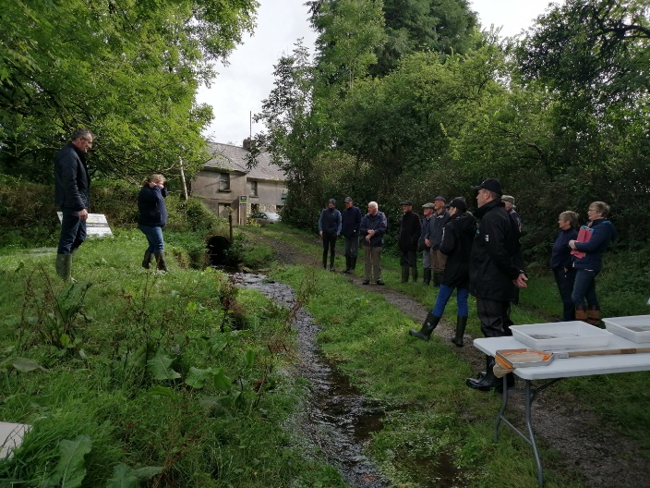 | 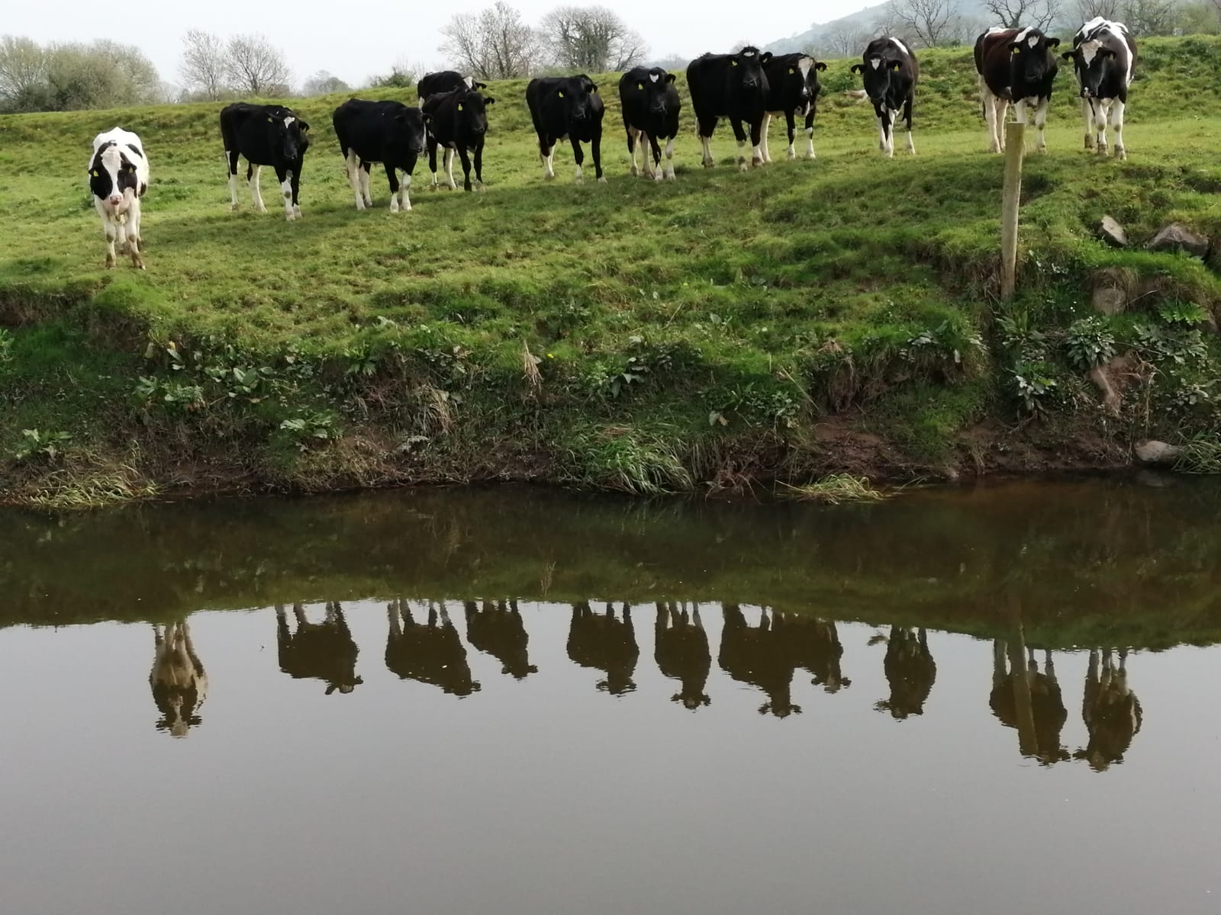
Operational Group working with local stakeholders in the Mulkear catchment area © Mulkear EIP project | Cows grazing the Mulkear catchment area © Mulkear EIP project
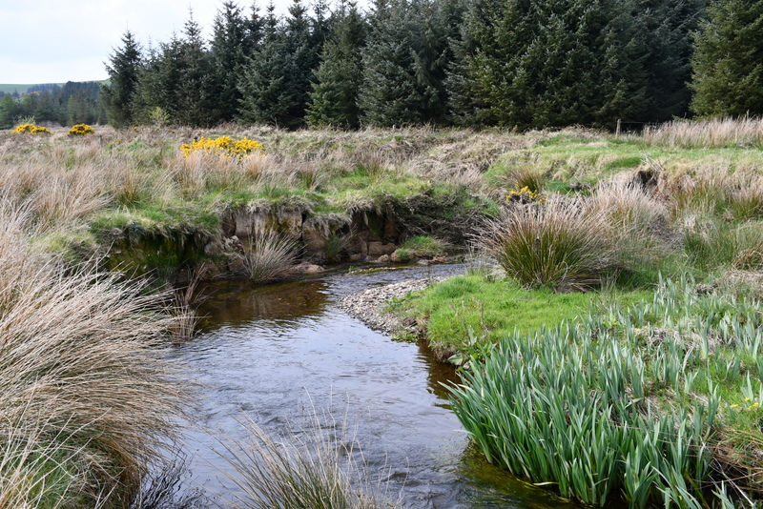
Mulkear catchment area © Mulkear EIP project

New EIP-AGRI Focus Group on Nature-Based Solutions for water management under climate change
The European Commission is currently looking for 20 experts for the European Innovation Partnership 'Agricultural Productivity and Sustainability' (EIP-AGRI) to start a new Focus Group on “Nature-Based Solutions for water management under climate change”. The deadline for application is Tuesday 11 January 2022. The first meeting is scheduled to be held 22-23 March 2022.

The EIP-AGRI Focus Group will bring together 20 selected experts, including farmers or foresters, advisers, researchers and agri-business representatives, to collect and summarise knowledge on best practices in a specific field, listing problems as well as opportunities. They take stock of the state of play in research and practice and highlight possible solutions to the problems identified. Based on this, the group suggests and prioritises innovative actions. It identifies ideas for applied research and for testing solutions in the field, and proposes ways to disseminate good practices and inspire further action related to Nature-Based Solutions for water management under climate change.

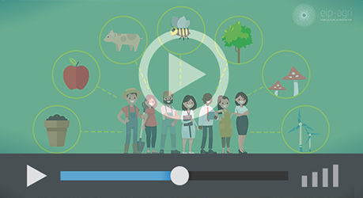

EIP-AGRI Focus Groups, sharing knowledge to inspire innovation

EIP-AGRI activities on water management
- EIP-AGRI Workshop 'Connecting innovative projects: Water & Agriculture'. Read the final report
- EIP-AGRI Focus Group “Water & agriculture: adaptive strategies at farm level” looked at farm level adaptation strategies to deal with water scarcity. Read the final report - factsheet

More related EIP-AGRI Water topics:
  - EIP-AGRI Brochure Water and Agriculture (EN, BU, HU, PT)
- EIP-AGRI Factsheet Water & Agriculture (EN, CZ, ES, FR, GR, IT, NL, PT)
- Booklet on innovative projects represented at EIP-AGRI Workshop: Connecting innovative projects: Water & Agriculture

EIP-AGRI inspirational examples on water-related topics
Below you can find a list of topics that have been covered in one of the EIP-AGRI publications.

EU | Fertinnowa: Thematic network to improve water management in fertigated crops | News
France | Mixed farming in the Aveyron river basin | Inspirational idea
Germany | Web-based information and advisory system help German fruit growers optimise returns | Press article
Italy/Spain | Dealing with water scarcity | Inspirational idea
Netherlands | Towards a circular horticulture system | Inspirational idea
Netherlands | Purified water from the food industry for agriculture | News
Portugal | Preserving soil organic matter and protecting water sources | Inspirational idea
Spain | Sensor technology optimises expensive and scarce water in Spanish greenhouses | Press article
Spain | Forests for wood, water, food and fun | Inspirational idea
Spain | 'Mission possible' to preserve wetlands in Spain | Inspirational idea
Spain | Measuring the water footprint of precision horticulture | Agrinnovation magazine N°6 – p16
Spain | Smart irrigation in La Mancha | EIP-AGRI brochure ‘Water &  Agriculture’
UK | UK Dealing with water scarcity on the farm | EIP-AGRI brochure ‘Water &  Agriculture’

EIP-AGRI projects on water management
Operational Groups in your country

At the beginning of December 2021, the EIP-AGRI Operational Groups database on the EIP-AGRI website included 261 Operational Groups in the EU working on water management:

- Austria: 1
- Belgium: 1
- France: 20
- Germany: 17
- Hungary: 1
- Ireland: 9
- Italy: 50
- Lithuania: 1
- Netherlands: 59
- Portugal: 16
- Slovenia: 6
- Spain: 76
- Sweden: 1
- UK: 3

Horizon 2020 multi-actor projects and thematic networks
- FATIMA - FArming Tools for external nutrient Inputs and water Management: website - CORDIS (03/2015-02/2018)
- FERTINNOWA - Transfer of INNOvative techniques for sustainable WAter use in FERtigated crops: website - CORDIS (Thematic network – 01/2016-12/2018)
- SolACE - Solutions for improving Agroecosystem and Crop Efficiency for water and nutrient use: website - CORDIS (05/2017-04/2022)
- WATERPROTECT - Innovative tools enabling drinking WATER PROTECTion in rural and urban environments: website - CORDIS (06/2017-05/2020)
- RECONECT - Regenarating ECOsystems with Nature-based solutions for hydro-meteorological risk rEduCTion: website – CORDIS (09/2018 – 08/2024)
- OPERANDUM - OPEn-air laboRAtories for Nature baseD solUtions to Manage environmental risks: website – CORDIS (07/2018-06/2022)
More Horizon 2020 multi-actor projects and Horizon 2020 thematic networks working on water are available at the EIP-AGRI website

The CAP of the Future
The reform of the Common Agricultural Policy (for 2023-2027) has been formally approved end November 2021. Find all information on the new CAP on the European Commission website.

Innovation & knowledge exchange | EIP-AGRI
The European Innovation Partnership 'Agricultural Productivity and Sustainability' (EIP-AGRI) has been launched in 2013 by the European Commission in a bid to promote rapid modernisation of the sectors concerned, by stepping up innovation efforts. The EIP-AGRI aims to foster innovation in the agricultural and forestry sectors and in rural areas by bringing research and practice closer together – in research and innovation projects as well as via the EIP-AGRI network. Also grassroots ideas from farmers get developed into innovations through the so-called Operational Group innovation projects. The EIP-AGRI aims to streamline, simplify and better coordinate existing instruments and initiatives, and complement them with actions where necessary.

EIP-AGRI Operational Groups
- 98 Rural Development Programmes provide support to innovative EIP Operational Group projects *
- Over 3200 Operational Groups are planned to be established under the approved RDPs (2014 – 2020)
- More than 2000 Operational Groups projects have been selected for funding and are currently ongoing (or already finished)*. Member States will still start more Operational Group projects which may run until 2025 (under current transitional rules for EU rural development programmes). Find information on all of them in the EIP-AGRI database.

* Information officially submitted to the European Commission by RDP Managing Authorities (November 2020)

EIP-AGRI Operational Groups are groups of people who work together in an innovation project funded by Rural Development Programmes (RDPs). They bring together partners with complementary knowledge. The composition of the group will vary according to the theme and specific objectives of each project. Farmers, advisers, scientists, businesses or other relevant partners work together to find practical solutions for specific problems or opportunities for European farmers and foresters. Farmers and foresters need to be cooperating throughout the project to ensure that the innovative solutions are practical and likely to be quickly applied in the field. Read the basic principles. Innovation support services (including advisers with a focus on innovation), and in particular innovation brokering, can therefore play a crucial role in getting worthwhile projects off the ground by facilitating contacts.

Check out the section on the EIP-AGRI website dedicated to 'Operational Groups', including:
- more than 2000 Operational Groups available in the database
- detailed information on how to set up Operational Groups, on supporting networks and relevant EIP-AGRI seminars and workshops
- links to results and contact details of ongoing Operational Groups in the EIP-AGRI database
- a list of all RDP Managing Authorities

EIP-AGRI videos
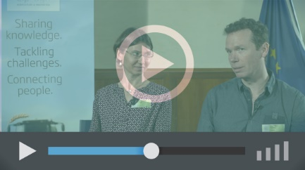
Operational Groups – first experiences | Operational Groups – collaborate to innovate
Innovation Support Services, supporting innovation in EU farming and forestry | AKIS: building effective knowledge flows across Europe
EIP-AGRI, 7 years of innovation

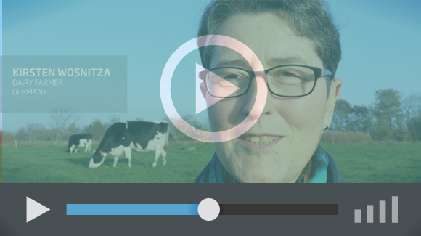 |  | The enthusiasm of the EIP-AGRI network members is essential to the success of the EIP-AGRI, and in ensuring that everyone can benefit. Watch this EIP-AGRI video to hear researchers, farmers, advisers, Managing Authorities and National Rural Networks explain how the EIP-AGRI has helped them over the past 7 years.
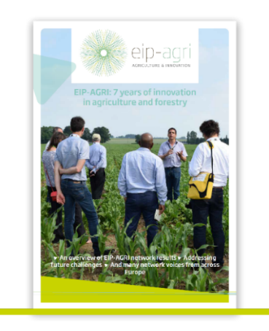 | Since 2013, the EIP-AGRI has been promoting interactive innovation to make EU agriculture and forestry more sustainable, productive, and fit for the future. This report shows how the EIP-AGRI network has grown into a thriving network. Read the report

