A smart label to build trust with consumers

Operational Group SMA.LA.WI., has developed a smart label which you can scan with your smartphone to read more about the specific wine you are buying. Their aim is to help guarantee the authenticity of high-quality Italian Veneto wines by strengthening the trust between producers and consumers.

The project partners identified that consumers tend to be less familiar with the Protected Geographical Indication (PGI) classification than with the better-known Protected Designation of Origin PDO one. Veneto PGI wines are often perceived as less prestigious and wineries struggle to make their quality known. PGI wines must be made from grapes from the region. However, they are not required to follow any criteria regarding production method, grape variety or aging specifications, but this does not limit their quality or traditional values. Digital marketing tools such as smart labelling and QR codes can bring more visibility to a product and improve the position of the producer in the agri-food value chain.

Operational Group SMA.LA.WI., is coordinated by winery Ottella run by brothers Francesco and Michele Montresor. They grow their own grapes, and they produce, market and sell their wine in the EU and beyond. The project also involves the University of Verona (departments of Business Economics and Computer Science) and Vignaioli Veneti, a cooperative of high-quality Veneto wine producers.

“We believe that when a consumer is buying a bottle of wine, they should be able to discover the territorial value of the products, production processes as well as corporate values and identity of the producing company” says Michele, “Consumers are increasingly analytical, wanting to know about the products they are buying, not only the place of origin but also the values of the producer.” So the partnership aimed to design a smart label which could make this information instantly available to the consumer through an app on their smartphones, going beyond the PGI requirements of what wines have to present on their label. The objective is to create a connection to the consumers, reassuring them about the quality and authenticity of the product. By reconstructing relationships in the supply chain, the project ultimately aims to reduce the gap between PGI and PDO wines. “You can geolocalise the productions, and you can find out about the company’s protocols concerning environmental sustainability”, Michele explains.

The project partners identified 5 wineries, all members of the Vignaioli Veneti cooperative to use as case studies. Michele tells us: “We began with a strategic analysis of the wineries in terms of their products, their objectives and needs.” The partners also carried out a survey among consumers about the use of the app. Each winery selected one wine for the case study; at the Otella winery they chose a high-value PGI red wine. The next step was to draw up the basic information to be included in the smart label, including product quality, traceability of inputs and production processes, sustainability protocols implemented by the wineries – “A sort of identity card for each wine” says Michele. A cloud platform was set up where this information was uploaded in different languages.

In parallel, the partners, led by the University of Verona, defined an encryption system for the QR code as well as a watermarking system for the label and the bottle. In the next stage, the case-study labels were printed and the bottles commercialised on the market.

The QR code also enables the producers to have some information on their consumers through data that is collected automatically. This can be useful for the producer. The first analysis of this data will be carried out over the next few months, but as Michele explains, “I have already had positive feedback from customers in the USA and China, who have found the app very useful to learn more about our wine production process”

The Operational Group will end this year. Michele hopes to set up a new project to involve more of the producers from the Vignaioli Veneti cooperative, and to extend the use of the smart label to all of the wines.

Background information
The Support Facility 'Innovation & Knowledge exchange | EIP-AGRI' offers support to foster smart and resilient agricultural, forestry and rural sectors, and food security to adress 3 objectives set in the new Common Agricultural Policy: support viable farm income and resilience across the EU territory to enhance food security, enhance market orientation and increase competitiveness including greater focus on research, technology and digitalisation and improve farmers' position in the value chain.

Project information
Contact: Michele MONTRESOR - info@ottella.it +39 0457551950
- Project page on EIP-AGRI Operational Group database
- Project website: https://www.smalawi.it/
- Video (in Italian, auto-translate available)

Project photos
Click on the pictures to download the high resolution versions. The pictures are free for use, please mention the copyright.

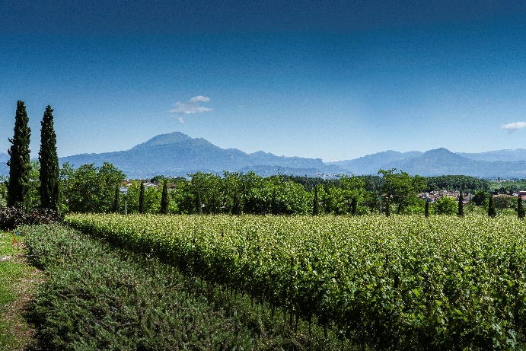 | 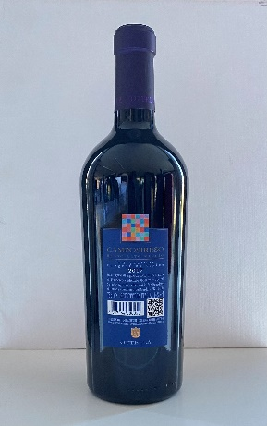
“We believe that when a consumer is buying a bottle of wine, they should be able to discover the territorial value of the products, production processes as well as corporate values and identity of the company who produces them” says Michele, winegrower at Otella winery. © Ottela | Digital marketing tools such as smart labelling and QR codes can bring more visibility to a product and improve the position of the producer in the agri-food value chain. © Ottela

More information on farmers in the value chain

EIP-AGRI activities

- EIP-AGRI Focus Group Short Food Supply Chain
- EIP-AGRI Workshop Cities & Food
- EIP-AGRI Workshop Innovation in the supply chain: creating value together

- EIP-AGRI Factsheet Cities & Food
- EIP-AGRI Factsheet Short Food Supply Chain
- Agrinnovation magazine n°4 – with many Short Food Supply Chain examples
- Brochure 'Innovation in short food supply chains'

Horizon 2020 multi-actor projects
- SKIN - Short supply chain Knowledge and Innovation Network: website - CORDIS (Thematic network – 11/2016-10/2019)
- SMARTCHAIN - Towards Innovation-driven and smart solutions in short food supply chains: website - CORDIS (09/2018-08/2021)
- COFRESH – CO-creating sustainable and competitive Fruits and vEgetableS’ value cHains in Europe: website - CORDIS (2020 – 2024)
Multi-actor projects are projects in which end users and multipliers of research results such as farmers and farmers’ groups, advisers, enterprises and others, are closely cooperating throughout the whole research project period.
Thematic networks are multi-actor projects which collect existing knowledge and best practices on a given theme to make it available in easily understandable formats for end-users such as farmers, foresters, advisers etc.

Operational Groups

97 Operational Groups working on (short) supply chain are available in the EIP-AGRI Operational Groups database (update 11 May 2022)
- France: 6
- Germany: !
- Ireland: 2
- Italy: 22
- Ireland: 2
- Latvia: 2
- The Netherlands: 27
- Poland: 1
- Portugal: 6
- Slovenia: 3
- Spain: 13
- Sweden: 5
- UK: 1

Inspirational ideas
EU | Moya Kneafsey: 'Reconnecting Cities, Farmers and Food: Why and how?' (TED talk) | Presentation workshop Cities & Food
Austria | Bernhard Kromp: 'Criteria for Green Public Food Procurement in Vienna: Status Quo and perspectives' | Presentation workshop Cities & Food
Austria | Bauernkiste | Final report Focus Group SFC p. 74
Belgium | Smart logistics to connect producers and consumers | Inspirational idea
Belgium | Patrick Pasgang: 'Distribution of added value in the chain: cases from Belgium' | Presentation workshop Cities & Food
Belgium | Distrikempen - A B2B logistics platform between farmers and clients | Final report Focus Group SFC p. 69
Czech Republic | Selling dairy products from a milk van | Inspirational idea
Denmark | Betina Bergmann Madsen: 'Inspiration for the future - Green public procurement in the municipality of Copenhagen' | Presentation workshop Cities & Food
Estonia | The Farm Market Co-operative | Final report Focus Group SFC p. 47
France | Bastien Farges: 'Connecting Consumers and Producers - Funding innovative projects' | Presentation workshop Cities & Food
France | Gilles Marechal: 'Land for young farmers and SFCs in Brittany' | Presentation workshop Cities & Food
France | Ici.C.Local participatory labelling system | Final report Focus Group SFC p. 50
France | Facilitating Access to Land for Agri-Rural Innovations | Final report Focus Group SFC p. 62
France | Aronia and other organic superberries in Centre-Val de Loire | Inspirational idea
Greece | Fresh farm milk for city dwellers | Agrinnovation n°4 – p. 7
Hungary | “HÁZIKÓ’s fresh treats connect the city and countryside” | Final report Focus Group SFC p. 67
Hungary | Exchanging knowledge for short food supply chain succes | Inspirational idea
Italy | Maria Bottiglieri: 'Good practices to fulfill the Right to Food of Turin citizens' | Presentation workshop Cities & Food
Italy | An Edible Park for citizens of Reggio Emilia | Inspirational idea
Lithuania | Healthy food and short supply chains | Inspirational idea
Montenegro | Food traceability from honey to hive | Agrinnovation n°4 – p. 16
Netherlands | Jan Willem Van Der Schans: ‘Distribution of added value in the chain’ | Presentation workshop Cities & Food
Netherlands | Mark Frederiks: 'Local2Local, a business model to access new markets in Utrecht region' | Presentation workshop Cities & Food
Netherlands | Landwinkel - A Farmer-Led Co-operative of ‘Country Shops’ | Final report Focus Group SFC p. 44
Netherlands | Producer and Consumer Collaboration | Final report Focus Group SFC p. 64
Netherlands | Food Value: online marketplace for local food chains | Inspirational idea
Poland | Marta Jeruszka Bielak: 'I know what I eat: Education and awareness raising about the importance of good fod systems in schools and kindergartens in Warsaw' | Presentation workshop Cities & Food
Poland | Mark Füssel: 'Public campaigning for organic local food' | Presentation workshop Cities & Food
Poland | Local products from Malopolska | Final report Focus Group SFC p. 37
Slovenia | Delivering local food to consumers in Ljubljana | Inspirational idea
Spain | Re-building relationships in short supply chain | Inspirational idea
Spain | Nerea Móran: 'Madrid: Urban gardens as part of the City Food System' | Presentation workshop Cities & Food
UK | “We don’t just sell products, we sell the experience!” | Inspirational idea
UK | Rob Alderson: 'Short supply chains in Manchester' | Presentation workshop Cities & Food
UK | Duncan Catchpole: 'How to run a successful short food supply chain enterprise in Cambridge, Box Schemes and Food Hubs' | Presentation workshop Cities & Food

The CAP of the Future
The reform of the Common Agricultural Policy (2023-2027) has been formally approved end November 2021. One of the 10 CAP objectives is to improve the position of farmers in the food chain. Find all information on the new CAP on the European Commission website.

Innovation & knowledge exchange | EIP-AGRI
The European Innovation Partnership 'Agricultural Productivity and Sustainability' (EIP-AGRI) has been launched in 2013 by the European Commission in a bid to promote rapid modernisation of the sectors concerned, by stepping up innovation efforts. The EIP-AGRI aims to foster innovation in the agricultural and forestry sectors and in rural areas by bringing research and practice closer together – in research and innovation projects as well as via the EIP-AGRI network. Also grassroots ideas from farmers get developed into innovations through the so-called Operational Group innovation projects. The EIP-AGRI aims to streamline, simplify and better coordinate existing instruments and initiatives, and complement them with actions where necessary. More information at the ‘About section’ of the EIP-AGRI website.

EIP-AGRI Operational Groups
- 98 Rural Development Programmes provide support to innovative EIP Operational Group projects *
- Over 3200 Operational Groups are planned to be established under the approved RDPs (2014 – 2020)
- More than 2400 Operational Groups projects have been selected for funding and are currently ongoing (or already finished)*. Member States will still start more Operational Group projects which may run until 2025 (under current transitional rules for EU rural development programmes). Find information on all of them in the EIP-AGRI database.

* Information officially submitted to the European Commission by RDP Managing Authorities (November 2020)

EIP-AGRI Operational Groups are groups of people who work together in an innovation project funded by Rural Development Programmes (RDPs). They bring together partners with complementary knowledge. The composition of the group will vary according to the theme and specific objectives of each project. Farmers, advisors, scientists, businesses or other relevant partners work together to find practical solutions for specific problems or opportunities for European farmers and foresters. Farmers and foresters need to cooperate throughout the project to ensure that the innovative solutions are practical and likely to be quickly applied in the field. Read the basic principles. Innovation support services (including advisors with a focus on innovation), and in particular innovation brokering, can therefore play a crucial role in getting worthwhile projects off the ground by facilitating contacts.

Check out the section on the EIP-AGRI website dedicated to 'Operational Groups', including:
- more than 2400 Operational Groups available in the database
- detailed information on how to set up Operational Groups, on supporting networks and relevant EIP-AGRI seminars and workshops
- links to results and contact details of ongoing Operational Groups in the EIP-AGRI database
- a list of all RDP Managing Authorities

EIP-AGRI videos
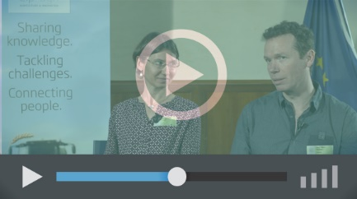
Operational Groups – first experiences | Operational Groups – collaborate to innovate
 | 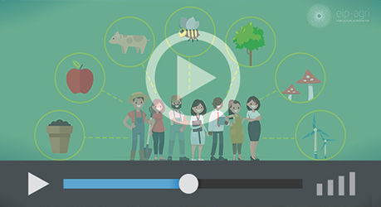
Innovation Support Services, supporting innovation in EU farming and forestry | EIP-AGRI Focus Groups, sharing knowledge to inspire innovation
AKIS: building effective knowledge flows across Europe

EIP-AGRI, 7 years of innovation

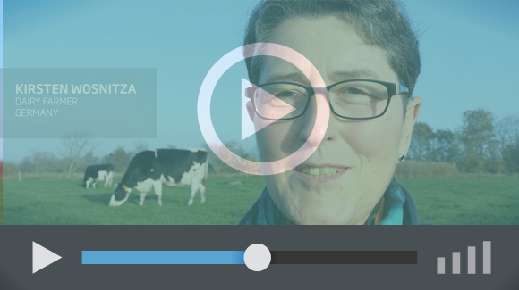 |  | The enthusiasm of the EIP-AGRI network members is essential to the success of the EIP-AGRI, and in ensuring that everyone can benefit. Watch this EIP-AGRI video to hear researchers, farmers, advisors, Managing Authorities and National Rural Networks explain how the EIP-AGRI has helped them over the past 7 years.
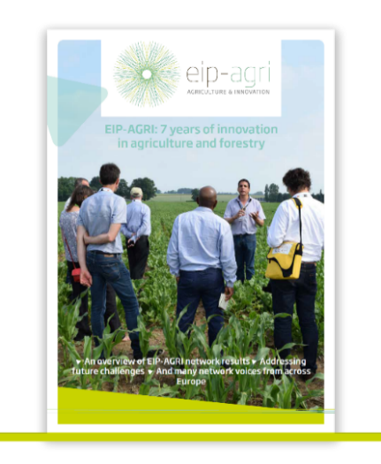 | Since 2013, the EIP-AGRI has been promoting interactive innovation to make EU agriculture and forestry more sustainable, productive, and fit for the future. This report shows how the EIP-AGRI network has grown into a thriving network. Read the report

