Press article long

Benefits and challenges of digital applications on the farm

Danish farmer Knud Bay-Smidt shares his experiences with digital tools

Danish farmer Knud Bay-Smidt started his own farm in 1987 cultivating grains, oilseed and grass seed on his 300 hectares of land. At the moment, he is using several digital applications. What are the benefits, but also challenges that he is facing?

Knud: “The Danish Ministry of Agriculture makes it very easy for farmers to get started with digital tools. For instance, they give free access to a programme called Crop Sat as well as some training to use it. Crop Sat enables you to download a satellite map of your fields, you can insert the desired amount of nitrogen for example, and it gives you the right amount of fertiliser. Another application that I’m using is FarmTrack. This is a simple GPS tracking device that is fitted to tractors and farm vehicles to track their movements. It helps to check if the correct amount of fertiliser is being applied on the field and at the right speed. The app can also be used as a notebook, so I also use it to mark the places in my field where I found weeds for instance.”

According to Knud, there are many benefits when it comes to using digital applications. “They give you more detailed knowledge about your soil, its nutrition content and yield potential. If you apply fertiliser very precisely, it can prevent overlap which minimises the risk of lodging.”

But using digital applications is also challenging. Knud: “The main challenge is that I have to use different digital tools. I only seed in April and September, therefore the tool I’m using for this is only be used twice a year, so it’s difficult to get familiar and fully master it. Together with this also comes the challenge of how to pick the technology that suits your needs, because there are many opportunities. Another thing I’m struggling with is the language that software developers use. They use a lot of words that we as farmers don’t use, which sometimes makes it difficult to understand.

“In my view, the best way to get started is to ask other farmers about the digital tools they are using. Internet forums are very useful for this too. Right now in times of the Covid-19 epidemic, digital technologies are also proving to be essential. My agricultural adviser isn’t able to visit my farm, so instead I have sent him photos of my crops. I also joined a webinar about software that helps to create prescription maps.”

“Always keep in mind, in the beginning it’s not easy to work with digital tools. You learn by doing. The capability to get the full benefits of the precision technology is an ongoing process and we have just entered it. Luckily, the suppliers of most digital tools offer some hours of training through a free training course, which makes it easier to get started. And, if you are not convinced yet, look at the digital success of the neighbouring farms.”

Press article short

Benefits and challenges of digital applications on the farm

Danish farmer Knud Bay-Smidt shares his experiences with digital tools

Danish farmer Knud Bay-Smidt started his own farm in 1987 cultivating grains, oilseed and grass seed on his 300 hectares of land. At the moment, he is using several digital applications. What are the benefits, but also challenges that he is facing?

Knud: “The Danish Ministry of Agriculture makes it very easy for farmers to get started with digital tools. For instance, they give free access to a programme called Crop Sat as well as some training to use it. Crop Sat enables you to download a satellite map of your fields, insert the desired amount of nitrogen for example, and it gives you the right amount of fertiliser.”

According to Knud, there are many benefits when it comes to using digital applications “They give you more detailed knowledge about your soil, its nutrition content and yield potential. If you apply fertiliser very precisely, it can prevent overlap which minimises the risk of lodging.”

But using digital applications can also be challenging. “The main challenge is that I have to use different tools for different activities. I only seed in April and September, therefore the tool I’m using for this is only used twice a year.”

“In my view, the best way to get started is to ask other farmers about the digital tools they are using. Internet forums are very useful for this too. And you learn by doing. Luckily, the suppliers of most digital tools offer some hours of training through a free training course. If you are not convinced yet, look at the digital success of neighbouring farms.”

Background information
Knud Bay Smidt presented his case during the EIP-AGRI seminar on new skills for digital farming –
5-6 February 2020 in Madrid, Spain. This case was one of the 13 poster presentations.

Project information

Contact person
Knud Bay-Smidt - kbs@skylinemail.dk
Twitter account: @BayKbs

- Crop Sat website: https://cropsat.com/
- Project poster as shown during the EIP-AGRI seminar on new skills for digital farming
- Testimonial video: digital skills on the farm: Knud Bay Smidt - Denmark

EIP-AGRI contact
Ina Van Hoye
Communication officer
EIP-AGRI Service Point
ina.vanhoye@eip-agri.eu
+32 486 90 77 43

Pictures
Click on the pictures to download the high resolution version. The pictures are free for use. Please mention the copyright: Knud Bay-Smidt

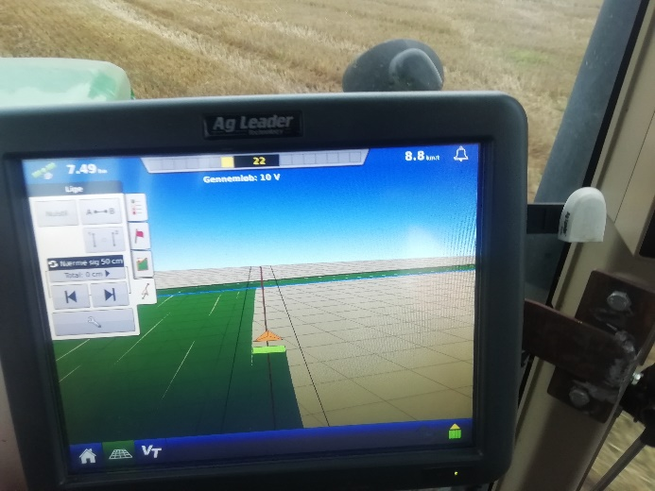 | 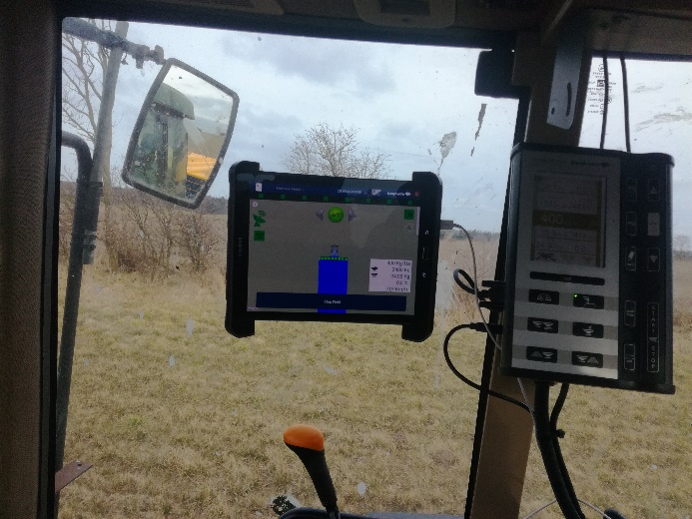
Knud Bay-Smidt: “There are many benefits when it comes to using digital applications. “It gives you more detailed knowledge about your soil, its nutrition content and yield potential. If you apply fertiliser very precisely, it can prevent overlap which minimises the risk of lodging.”

More EIP-AGRI information on digitalisation
The EIP-AGRI has done many different activities related to digitalisation

- EIP-AGRI Focus Group on Mainstreaming Precision Farming
- EIP-AGRI workshop on data sharing
- EIP-AGRI Seminar "Digital Innovation Hubs: mainstreaming digital agriculture"
- EIP-AGRI seminar: Multi-level strategies for digitising agriculture and rural areas
- EIP-AGRI seminar ‘New skills for digital farming’

EIP-AGRI publications

- EIP-AGRI Brochure Digital evolution in agriculture – available in English, French, German, Hungarian, Latvian, Romanian, Slovenian
- EIP-AGRI factsheet Digital (r)evolution, with EIP-AGRI scope and links to previous EIP-AGRI events, inspirational ideas, funding opportunities,… related to digitilisation
- The Agrinnovation magazine 2018 focused on digitalisation (available in English and Greek)
- In February the EIP-AGRI Service Point launched a digitalisation thematic campaign, including a social media campaign #EIPagriDigi to highlight their EIP-AGRI activities and the February 2020 EIP-AGRI newsletter focussing on digitalisation (also available in French, Estonian, Romanian, Slovakian)

Be inspired by digital technologies and innovative projects for the farming and forestry community at the ‘digital agriculture’ section at the EIP-AGRI website and find out how to improve your digital knowledge and skills.

Horizon 2020 multi-actor projects working on digitalisation

- 4D4F - Data Driven Dairy Decisions 4 Farmers: website - CORDIS (Thematic network- 03/2016-02/2019)
- SMART-AKIS - European Agricultural Knowledge and Innovation Systems (AKIS) towards innovation-driven research in Smart Farming Technology: website - CORDIS (Thematic network – 03/2016-08/2018)
- IoF2020 - Internet of Food and Farm 2020: website - CORDIS (Multi-actor project 01/2017-12/2020)
- SmartAgriHubs - Connecting the dots to unleash the innovation potential for digital transformation of the European agri-food sector: CORDIS (Multi-actor project 11/2018-10/2022)
- DESIRA - Digitisation: Economic and Social Impacts in Rural Areas: website - CORDIS (06/2019-05/2023)

Find out more about these projects at the multi-actor projects webpage at the EIP-AGRI website > Digital revolution
Multi-actor projects are projects in which end users and multipliers of research results such as farmers and farmers’ groups, advisers, enterprises and others, are closely cooperating throughout the whole research project period.
Thematic networks are multi-actor projects which collect existing knowledge and best practices on a given theme to make it available in easily understandable formats for end-users such as farmers, foresters, advisers etc.

Operational Groups working on digitilisation
249 Operational Groups working on digitalisation are available in the EIP-AGRI Operational Groups database (update 20 April 2020)
- Austria: 4
- Belgium: 3
- Finland: 6
- France: 6
- Germany: 49
- Italy: 62
- Latvia: 9
- Lithuania: 2
- Netherlands: 34
- Portugal: 8
- Slovenia: 4
- Spain: 43
- Sweden: 13
- UK: 6

Inspirational ideas on digitalisation
EU | Data sharing through Farmbench
Belgium, Netherlands | In- or outside? A digital tool to monitor grazing cows
Denmark | Improving welfare for cows… and farmers
Estonia, Netherlands | Agri-Hackathon
Estonia, Finland | Biosensors in dairy farming
Finland | Digitisation to improve AKIS
France | Farm demonstrations, discovering drones
France | Dealing with pests from the air
Germany | Complying with environmental regulations when spraying crops
Germany | A digital strategy for agriculture
Germany | Digital innovation goes beyond “technology”
Hungary | Data-driven technologies increase Hungarian milk yields and milk quality
Italy | A mobile app to monitor pests and diseases in Umbria, Italy
Ireland | Staying in tune with farm performance
Netherlands | Smart sensors to better understand plant growth
Netherlands | Sports apps for dairy cows!
Netherlands, EU | Food Value: online marketplace for local food chains
Netherlands | Precision farming- the right technology and sharing knowledge are key
Netherlands | FarmHackNL connects farmers with customers, techies and hackers
Portugal | Buzzing with innovation
Romania | Agriso
Slovakia | Decision support tool for dairy farm management
Slovenia | An app to find out where our food comes from
Spain | Forest monitoring for sustainable management
Spain | Olive groves and drones - science fiction turned reality
Sweden | A planning tool for reindeer husbandry
UK | Where have ewe moo-ved to?

EIP-AGRI
The European Innovation Partnership 'Agricultural Productivity and Sustainability' (EIP-AGRI) is one of five EIPs which have been launched by the European Commission in a bid to promote rapid modernisation of the sectors concerned, by stepping up innovation efforts. The EIP-AGRI aims to foster innovation in the agricultural and forestry sectors by bringing research and practice closer together – in research and innovation projects as well as via the EIP-AGRI network.
EIPs aim to streamline, simplify and better coordinate existing instruments and initiatives, and complement them with actions where necessary. Two specific funding sources are particularly important for the EIP-AGRI: the EU Research and Innovation framework, Horizon 2020, as well as the EU Rural Development Policy.

- EIP-AGRI Brochure on the EIP-AGRI Network (2015) (EN – BG – DE – ES – FR – GR – HU – IT – PT – RO)
- EIP-AGRI Brochure on Funding opportunities under Horizon 2020 – Calls 2020 Calls (EN)
- EIP-AGRI Brochure on Horizon 2020 Multi-actor projects (EN – BG – DE – FR – SI)
- EIP-AGRI Brochure on Thematic Networks under Horizon 2020 (EN – BG – DE – ES – FR – HU)

Contact information
Ina Van Hoye
Communication officer
EIP-AGRI Service Point
ina.vanhoye@eip-agri.eu
+32 486 90 77 43

